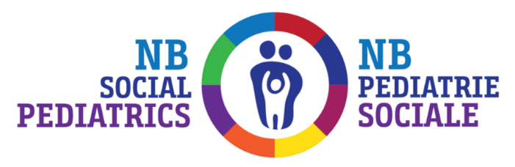
I am interested in participating in, or learning about, NB Social Pediatrics’ research.

A list of study topics and ways that families can participate in the research process are listed below. Please check any that are of interest to you.

 | Research Topics |  | Role
 | Prenatal Factors in Autism* |  | Research participant
 | Behaviour and Attention Issues |  | Patient Representative
 | Maternal Substance-Use Disorder* |  | Advisory Committee Member

Please note: completing this form gives the Research Team permission to contact you, only. You are not obligated to participate in any research.

Contact Info:
Name
Phone:
Best time to reach me:

Not taking part in our study does not impact your appointment or treatment with us.
Thank you for your interest and consideration

